Your first program
Eclipse is an IDE (Integrated Development Environment) for Java.
What is a Java Application?
A Java application is an application written to the Java Platform. The same unmodified Java applications can be run on almost any computer, whether that computer uses the Microsoft Windows, Solaris, Linux, or MacOS X operating systems. The key to this application portability is the Java Runtime Environment, which is available free of charge for most operating systems, including all of the ones mentioned above.
In addition to being a platform for multi-platform desktop applications, the Java SE platform is the basis for other technologies such as Java Platform, Enterprise Edition. You might find yourself writing Java code that provides back-end logic for web and enterprise applications as well.
Development tools
There are numerous Java IDEs – NetBeans, Eclipse and IntelliJ are some of the most common ones used in the software industry.

Download Eclipse | http://www.eclipse.org/downloads/  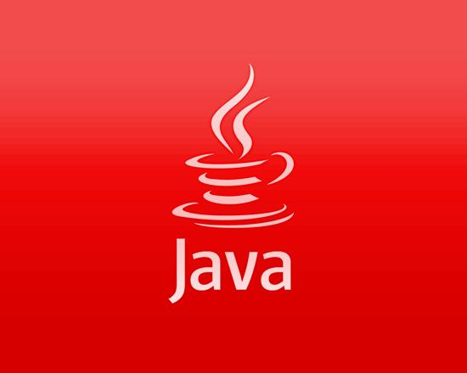
Download a suitable Java edition | http://www.oracle.com/technetwork/java/javaee/overview/index.html  JDK 8.0- http://www.oracle.com/technetwork/java/javase/downloads/jdk8-downloads-2133151.html
Java versions
JEE Java Enterprise Edition
Java Platform, Enterprise Edition is the industry standard for enterprise Java computing. The Java EE platform is developed through the Java Community Process (the JCP), which is responsible for all Java technologies. Expert groups, composed of interested parties, have created Java Specification Requests (JSRs) to define the various Java EE technologies.
JSE Java Standard Edition
A ‘light’ version of the JEE, targeted at workstation environments.
Setting Up the Project
To create an IDE project:
- Start Eclipse IDE.
- Run the Eclipse launcher program (e.g. C:\Program Files\eclipse\eclipse.exe) to bring up the IDE. Eclipse will open with a Welcome screen
- Please note: The first time you start Eclipse, you will be prompted for the location of your Workspace. The workspace is the location where your files and settings will be stored.
- In the IDE, choose File > New > Project.. as shown in the figure below.
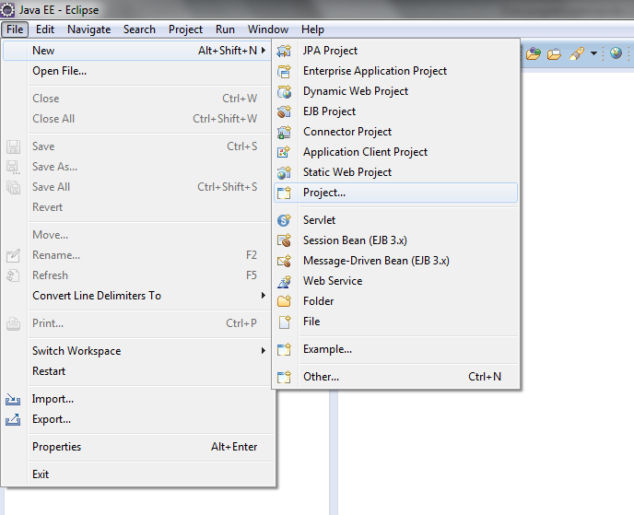
- In the New Project wizard,. Select Java Project click Next.
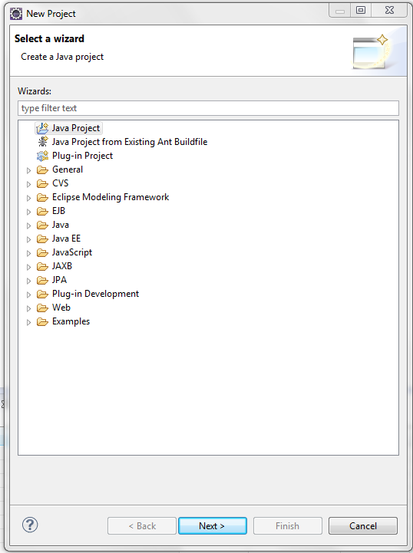

- Select and enter the following as shown below:
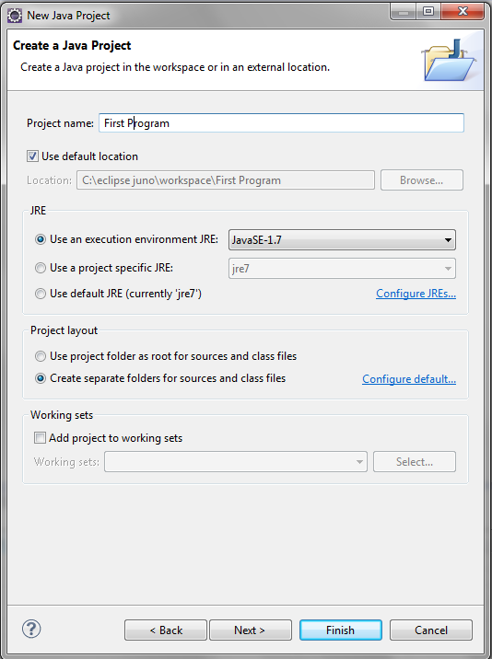
- Click Finish.

The project is created and opened in the Eclipse. You should see the following components:
- The Projects window, which contains a tree view of the components of the project, including source files, libraries that your code depends on, and so on.
- The Source Editor window.
- The Navigator window, which you can use to quickly navigate between elements within the selected class.

- Create a new Package – your first Java class will be held in it. (Right click on the src folder)
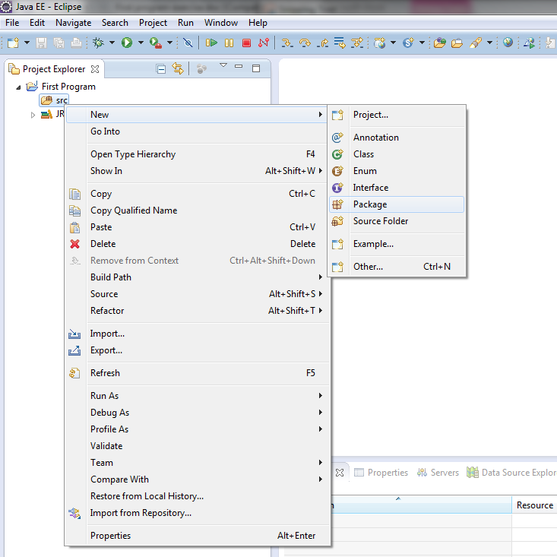

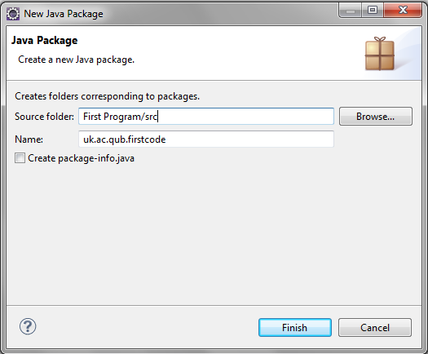

Create a class with the package (right click on the package .. )
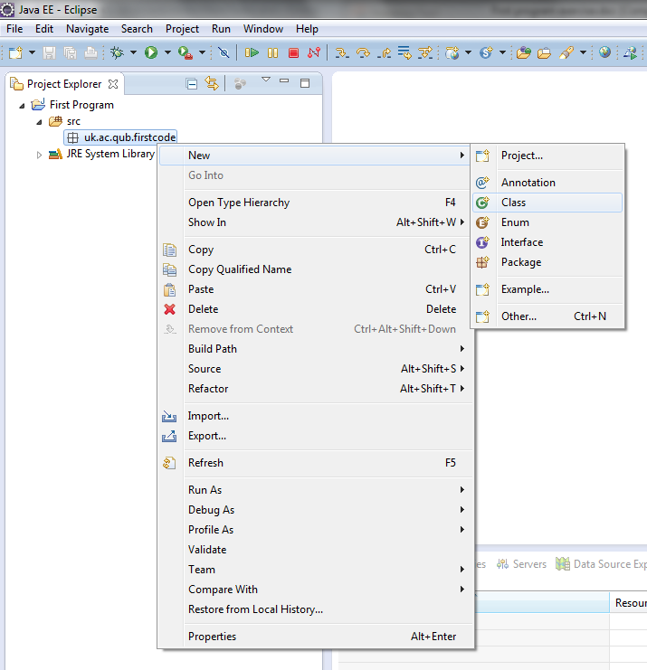

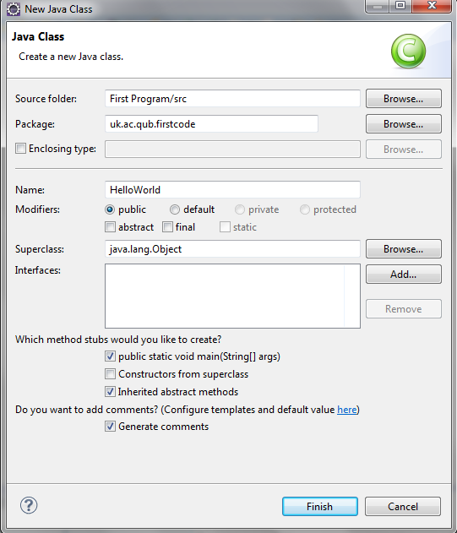
Select here to create a Main method
You should now have a view similar to this … (select the options as above)
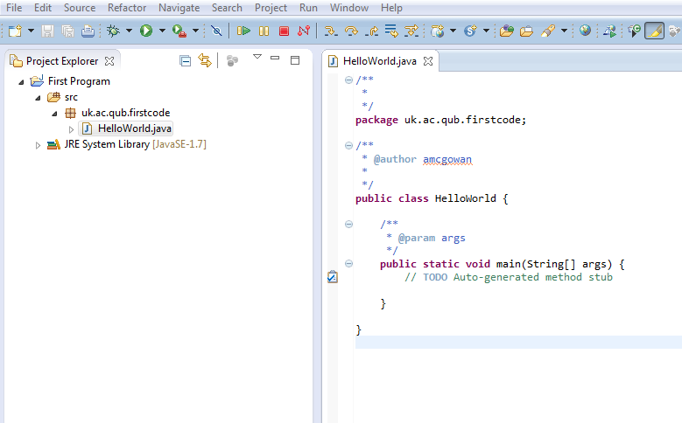

Adding Code to the Generated Source File
Because you have left the Create Main Class checkbox selected in the New Project wizard, the IDE has created a skeleton class for you. You can add the "Hello World!" message to the skeleton code by replacing the line:
// TODO code application logic here

with the line:
System.out.println("Hello World!");

Save the change by choosing File > Save.

The file should look something like the following:
/**
*
*/
package uk.ac.qub.firstcode;

/**
* @author amcgowan
*
*/
public class HelloWorld {

/**
* @param args
*/
public static void main(String[] args) {
System.out.println("Hello world");
}

}

Compiling the Source File
To compile your source file, choose Build > Build project from the IDE's main menu.
When you build the project, the bytecode file HelloWorldApp.class is generated. You can see where the new file is generated by opening the Files window and expanding the
workspace\First Program\bin\uk\ac\qub\firstcode

Now that you have built the project, you can run your program.

Running the Program
From the IDE's menu bar, choose Run > Run or Ctrl F11.
The next figure shows what you should now see.
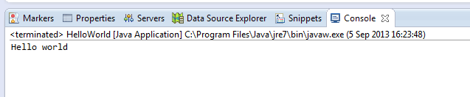
Congratulations! Your program works!

Binary representation of numbers
  - What kind of 'base' system is binary known as?
- Base 10
- Base 2
- Base 16

  - What kind of number system is used in everyday life?
- Denary
- Binary
- A simple number system

  - What would the denary number 199 be in 8 bit non signed binary?
- 11000110
- 10100111
- 11000111

  - What would the denary number 55 be in 8 bit non signed binary?
- 00110111
- 00101111
- 01010111

  - What would the denary number 6 be in 8 bit Two’s complement binary?
- 00010110
- 00111110
- 00000110

  - What would the denary number -6 be in 8 bit Two’s complement binary?
- 10000110
- 00111110
- 11111010

  - What would 10110010 (non signed) be as a denary number?
- 168
- 178
- 188
  - What would 00101110 (non signed) be as a denary number?
- 46
- 36
- 56


Binary Addition
0 + 0 = 0
0 + 1 = 1
1 + 0 = 1
1 + 1 = 0, carry 1 = 10
1 + 1 + 1 = 1 carry = 11
For example:
0 1 1 0 1
+ 1 0 1 1 1
---------------------
= 1 0 0 1 0 0

  - What is an overflow error?
- When the result of a binary calculation is too long for a computer to process
- When something is spelt incorrectly when programming
- When the computer program has been given the wrong command

  - Using Two’s complement …
1 0 1 1 0 1 0 1 (-75)
+ 0 0 1 1 1 0 1 1 (+59)
______________________________________________________
1 1 1 1 0 0 0 0 (-16)

  - Using Two’s complement …
0 0 1 0 1 1 0 0 (+44)
+ 0 0 1 0 1 1 0 1 ( +45)
_____________________________________________________
0 1 0 1 1 0 0 1 (+89)

  - Using Two’s complement … (hint Bit Bucket)
1 1 0 1 1 0 0 1 (-39)
+ 0 1 0 1 1 1 0 0 (92)
_____________________________________________________
1 0 0 1 1 0 1 0 1 (53)

